Tutorial No : 4

Tutorial Title: Write a program in C++ to perform following operations on complex numbers Add, Subtract, Multiply, Divide, Complex conjugate. Design the class for complex number representation and the operations to be performed. The objective of this assignment is to learn the concepts classes and objects
Name of Student: Aditya Jadhav
Class: ENTC Div: 2 PRN No: B25ET1133 Batch: C2
___________________________________________________________________________

Addition of Complex Numbers

#include <iostream>
using namespace std;

class Complex {
int real, imag;

public:
void input() {
cout << "Enter real part: ";
cin >> real;
cout << "Enter imaginary part: ";
cin >> imag;
}

Complex add(Complex c) {
Complex temp;
temp.real = real + c.real;
temp.imag = imag + c.imag;
return temp;
}

void display() {
cout << real << " + " << imag << "i";
}
};

int main() {
Complex c1, c2, result;

cout << "First complex number:\n";
c1.input();

cout << "Second complex number:\n";
c2.input();

result = c1.add(c2);

cout << "Sum = ";
result.display();

return 0;
}

Output

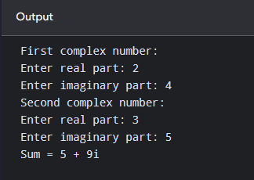

Subtraction of Complex Numbers
#include <iostream>
using namespace std;

class Complex {
int real, imag;

public:
void input() {
cout << "Enter real part: ";
cin >> real;

cout << "Enter imaginary part: ";
cin >> imag;
}

Complex subtract(Complex c) {
Complex temp;

temp.real = real - c.real;
temp.imag = imag - c.imag;

return temp;
}

void display() {
cout << real << " + " << imag << "i";
}
};

int main() {
Complex c1, c2, result;

cout << "First complex number:\n";
c1.input();

cout << "Second complex number:\n";
c2.input();

result = c1.subtract(c2);

cout << "Difference = ";
result.display();

return 0;
}

Output
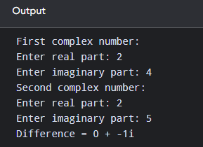

Multiplication Of Complex numbers
#include <iostream>
using namespace std;

class Complex {
int real, imag;

public:
void input() {
cout << "Enter real part: ";
cin >> real;

cout << "Enter imaginary part: ";
cin >> imag;
}

Complex multiply(Complex c) {
Complex temp;

temp.real = (real * c.real) - (imag * c.imag);
temp.imag = (real * c.imag) + (imag * c.real);

return temp;
}

void display() {
cout << real << " + " << imag << "i";
}
};

int main() {
Complex c1, c2, result;

cout << "First complex number:\n";
c1.input();

cout << "Second complex number:\n";
c2.input();

result = c1.multiply(c2);

cout << "Product = ";
result.display();

return 0;
}

Output\
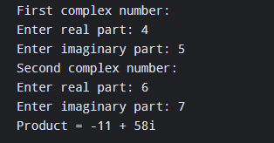

Division Of Complex Numbers
#include <iostream>
using namespace std;

class Complex {
float real, imag;

public:
void input() {
cout << "Enter real part: ";
cin >> real;

cout << "Enter imaginary part: ";
cin >> imag;
}

Complex divide(Complex c) {
Complex temp;

float denominator = (c.real * c.real) +
(c.imag * c.imag);

temp.real = ((real * c.real) +
(imag * c.imag)) / denominator;

temp.imag = ((imag * c.real) -
(real * c.imag)) / denominator;

return temp;
}

void display() {
cout << real << " + " << imag << "i";
}
};

int main() {
Complex c1, c2, result;

cout << "First complex number:\n";
c1.input();

cout << "Second complex number:\n";
c2.input();

result = c1.divide(c2);

cout << "Division = ";
result.display();

return 0;
}

Output
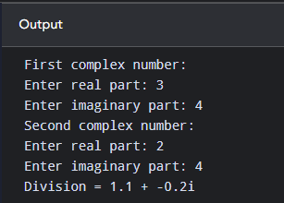

Conjugate Of Complex Number
#include <iostream>
using namespace std;

class Complex {
int real, imag;

public:
void input() {
cout << "Enter real part: ";
cin >> real;

cout << "Enter imaginary part: ";
cin >> imag;
}

Complex conjugate() {
Complex temp;

temp.real = real;
temp.imag = -imag;

return temp;
}

void display() {
cout << real << " + " << imag << "i";
}
};

int main() {
Complex c1, result;

cout << "Enter complex number:\n";
c1.input();

result = c1.conjugate();

cout << "Conjugate = ";
result.display();

return 0;
}

Output
